ZION LUTHERAN CHURCH
March 2024

Zion Lutheran Church
Stillwater Oklahoma
March 2024 Newsletter
Pastor Wackler

This March is a busy month for church people. Here at Zion we are having our Midweek Lenten services. These are based upon the God ordained festivals of the Old Testament Jewish people. All of these festivals ultimately point to Jesus. Our Lenten discipline will lead us to a congregational Seder meal on Maundy Thursday. There will be a sign up sheet for this coming out soon. Good Friday Service will be the Tenebrae service. Then, of course, we will celebrate the resurrection of our Lord on March 31.

As summer approaches, I encourage all with children to consider sending them to Camp Lutherhoma. Their material is on our bulletin board. Several of our student attendees here at Zion will be counselors at the Camp.

We continue to need ushers and others who serve. Please consider assisting our congregation by signing up for this way of serving.

At the end of our Wednesday evening service on March 21, we were greeted with a bat flying around our sanctuary. These are amazing creatures, but it's not good when one is dive bombing members in the pews. Elder Danny Fisher humanely captured the bat, and released it into the wild.

Our sister congregations at Perry, and Newkirk and rural Blackwell remain without pastors. At Perry, the search continues, and plans are being considered for the St. Johns of Kay County. Please remember them in your prayers.

The Lord bless you all with deep and abiding faith in our Savior Jesus.
Pastor Wackler

Sunday Services on YouTube
PASTOR WACKLER OFFERS PRIVATE COMMUNION
- At the church
- In your home
- On your comfort level
- Contact the church for more info

NEWS
Hospitality Sign-up Sheet for January-April is posted on the bulletin board in the Fellowship Hall.

LCMSU Meal Sign up Sheet is posted on the bulletin board in the Fellowship Hall.

Worship Assistants sign up board is located in the narthex if you would like to volunteer to help, please see the board for open opportunities.

2024 Altar Flower Chart is posted on the bulletin board in the Fellowship Hall, cost is $25 payable to the Altar Guild.

Monday – Thursday: Video devotions with Pastor: usually posted on Youtube and Facebook the evening before. Schedule of readings available.
Lutheran Women’s Missionary League – March 2024
2023–2025 Mission Grant No. 8
EXPANDING GOSPEL PROCLAMATION WORLDWIDE Concordia Seminary, St. Louis, Missouri | $100,000
Concordia Seminary is committed to addressing the concern of educating international students from countries that are unable to handle the significant financial obligation. This education will help to ensure that those living in every region of their nations will hear and learn the message of salvation through Christ. An LWML Mission Grant will provide scholarship aid for international students. To learn more, look up this mission grant at www.lwml.org/2023-2025-mission-grant-8. On February 12, 2024 the ladies of the LWML (and some of their spouses) gathered at MPower for a Valentine Party for the folks there. They played bingo and won lots of prizes. Blessings to you during this Lenten season. Reporter, Diane Wackler

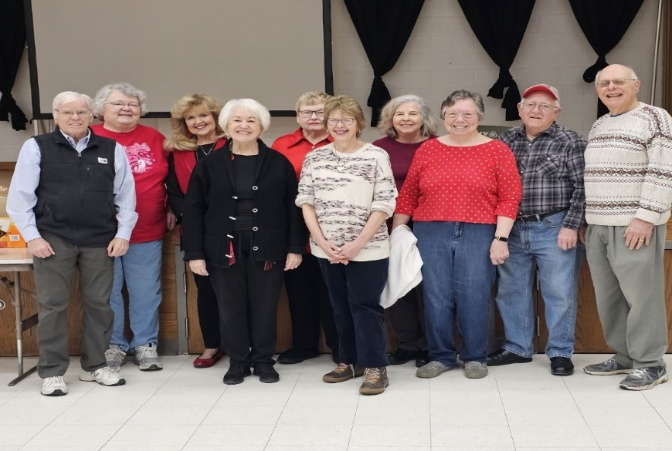

DATES TO REMEMBER
Zion Lutheran Winter 2024
Confirmation Class Sundays @ 9:15 am
Wednesdays Bible Study 10:30 am & 6:30 pm (hiatus until after Easter)
LCMSU Bible Study & Meal Tuesdays @ 6:30 pm
Men’s Breakfast 7:00 am (2nd Friday of the month)
SALT Bible Study 10:30 am (2nd & 4 Tuesday of the month)

Church Council March 4th @ 7:00 pm
Hymn Selection March 11th @ 5:00 pm
LWML March 19th @ 6:30 pm

Lenten Services Mar 6th, 13th, & 20th @ 10:30 am & 7:00 pm
Lenten Meals Mar 6th, 13th, & 20th @ 6:00 pm
Maundy Thursday Sedar Meal March 28th @ 7:00 pm
Good Friday Service March 29th @ 10:30 am & 7:00 pm
Easter Services March 31st @ 8:00 am & 10:30 am
Easter Brunch March 31st @ 9:15 am

March
BIRTHDAYS
3/4 Chuck Willoughby
Will Hentges
3/5 Doris McDaniel
3/6 Scotlynn Doty
3/7 Margaret Lawson
Pat Leader
3/8 Gage Hopper
3/12 Jared Keeler
3/16 Laura Hedrick
Melissa McDaniel
3/17 Simon Ringsmuth
3/18 Harl Hentges
3/19 Reid LeGrand
3/23 Tim Eggers
3/27 Shane Hoffman

ANIVERSARIES
3/28 Garvin & Clarice Quinn (31st)

Elder
Bob Bahr

Altar Guild: Flowers on the Altar:
3/3 (p) & 3/10 (p) Ann Hentges 3/3 Kulling Kristin birthday
3/17 (p) & 3/24 (r) Bev Bahr 3/17 Wolff in memory of Dale Wolff
3/31 (w) Susan Willoughby 3/31 Lilies

